A-TRACK D2.2b: Top-down demonstration of Nature Information Pathway framework

Introduction

Scope of task
With the recent adoption of the EU Corporate Sustainability Reporting Directive (CSRD), companies will be required to report on their environmental and social impacts according to the European Sustainability Reporting Standards (ESRS). The significant risk that biodiversity loss poses to business and societal functioning is reflected in the ESRS as an increased focus on biodiversity in alignment with the Kunming-Montreal Global Biodiversity Framework.
The need to meet the requirements of reporting directives has resulted in the development of a plethora of databases and tools, but a holistic method to manage biodiversity data, calculate indices and report impacts to comply with the CSRD remains lacking. GRI, TNFD, Nature Positive Initiative,...
Summary of D2.1 needs we’re addressing here.
Also mention what already exists but is not sufficient here for this specific scenario (eg JRC layers, INCA).
The complexity of reporting on biodiversity and site impacts in a spatially explicit way has created concerns over the reporting load for businesses, but also has the potential for using open remote sensing data. The use of high resolution remote sensing data to create habitat maps tackles the following challenges faced in the corporate application of NCA:
- Spatial nature of RS data and maps is highly relevant to evolving ESG reporting requirements and management of sites by businesses. For example ESRS and NPI state of nature metrics are strongly based in SEEA extent, condition and services, which require spatial measurement, and these metrics are necessary for businesses to manage the land they are custodians of.
- Spatial resolution – high enough spatial resolution for business sites, not available in public accounts. Also relevant to thematic resolution – at 10m res, we can identify specific habitats, which makes it possible to calculate threat metrics. Can more accurately see how business sites fit into and affect landscape, and determine responsibility of business.
- Temporal resolution – can be updated each year in a consistent manner, to produce comparable results and create an account. Useful for monitoring a site and subsequent management of sites/business practices
- Flexibility, ease of use by individual businesses for site-specific measurements – businesses can choose which places and metrics they want to investigate, relevant and specific to their own sites and business practices, and they can incorporate their own data. So it's top-down, but with greater situation relevance and reduced information overload and storage issues
- Data availability and comparability – high quality RS data that would be too expensive for most private businesses to personally commission, especially small businesses. Improves accessibility of data that are not usually available to individuals, as well as tools to structure large/messy open data. Use of semi-automated processes improves consistency (comparability, understandability, reliability) among inputs and outputs
In this deliverable we demonstrate the application of the Nature Information Pathway framework outlined in D2.2 for structuring public nature data to produce nature information relevant for private business applications, i.e. using a top-down approach.
Summary/relevant specifics of D2.2a that we will deal with here.

Main objectives
- Start to bridge gap from public to private NCA
- Test how this fits in with LCA to improve nature information
- Introduce, showcase, harmonise, explore feasibility... of tools
- Identify the main needs that underly a common data structure for using public data in private sustainability reporting
- Provide examples and a guide that businesses can follow
- Provide some training to key players
- Gain input from businesses on how useful this is
- Identify areas that cannot currently be estimated with EO

We will use three demonstration scenarios to approach these objectives:
- Demonstration 1 - Tracking impacts on stocks at priority locations
This case demonstrates how remote sensing data can be structured with Natural Capital Accounting principles and existing ESG reporting tools, to generate spatial metrics on the extent and condition of ecosystem types in and around business sites. The nature information set generated will be in line with the Nature Positive Initiative’s draft State of Nature metrics (2025), augmented with additional ecosystem condition metrics, relevant for corporate sustainability reporting and management of target habitats. This will be demonstrated for a case in the mining (extraction) sector.
- Demonstration 2 – Assessing potential impacts and dependencies across value chain through Life Cycle Assessment

- Demonstration 3 –

Case studies

Demo 1 – Tracking impacts on stocks at priority locations
Sibelco is a Belgian extraction company with more than 100 quarries throughout Europe, and a number in north America and Asia. Sibelco took part in the Nature Positive Initiative’s 2025 pilot programme to test the initiative’s draft State of Nature metrics. Vito acted as technical partner for Sibelco in this pilot by providing extent maps and collaboratively calculating the metrics for two sites, one in the United Kingdom and one in Borneo. Vito’s involvement was carried out in the context of A-Track Nature Information Pathway framework, by demonstrating the use of public data (vegetation plots and remote sensing data) as input into the framework, transforming the data into ecosystem extent maps for Sibelco’s business sites, and generating a nature information set based on the pilot State of Nature metrics augmented with additional ecosystem condition metrics of interest to Sibelco for use in sustainability reporting and business practice management. The production of these metrics is intended to serve as a practical demonstration of how existing frameworks and tools can be used to generate SEEA-aligned and business-relevant metrics, highlighting how the Nature Information Pathway framework presents opportunities to address data needs identified in D2.1, as well as identify knowledge and data gaps that remain.
Metric sources:
- Nature Positive Initiative State of Nature draft metrics for 2025 pilot program
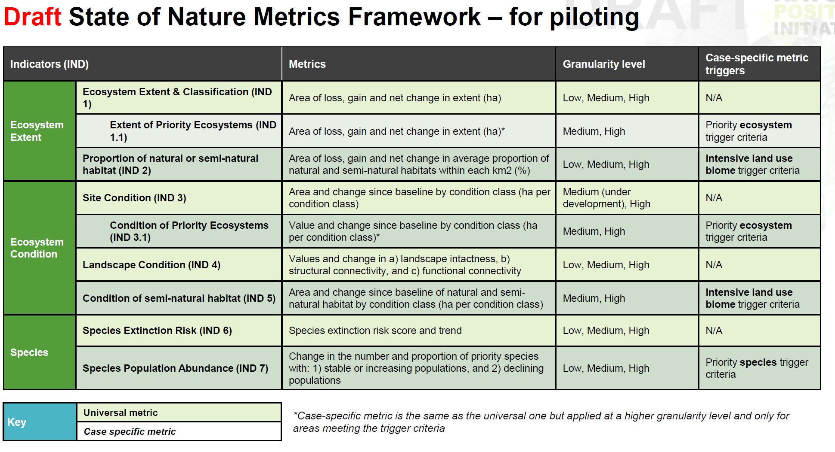
- ECOSYSTEM CONDITION ACCOUNTS – GUIDANCE NOTE, FOURTH DRAFT Doc. ENV/EA/TF/2023_3/x. Eurostat Task force on ecosystem accounting virtual meeting 27-28 September 2023
- Add other sources for condition indicators used

Target metrics to compile for Nature Information Set:
NPI indicator | Bent Farm (England) |  | Capkala (Borneo)
 | Metrics | Methods | Metrics | Methods
IND1: Ecosystem Extent | Ecosystem extent and change (in ha) of site +500m | Vito habitat mapping, Planet data validation, basic data analysis scripts | Ecosystem extent (and change?) of site + 1000 m | Manual delineation of ecosystem assets with local vegetation + land use maps + deforestation maps + global satellite imagery … , satellite imagery validation + ecological ground-truthing
IND1.1: Ecosystem Extent & Classification of Priority Ecosystems | Ecosystem extent and change (in ha) of site +500m | As above + crosswalk to IUCN Red List of Threatened Habitats, basic data analysis scripts | Ecosystem extent and change (in ha) of site +1000m | As above + crosswalk to IUCN Red List of Threatened Habitats
IND2: Proportion of Natural or Semi-Natural Habitat | Ecosystem extent and change (in ha) of site +500m | As above + crosswalk to natural/non-natural, basic data analysis scripts | As above + crosswalk to IUCN Red List of Threatened Habitats, basic data analysis scripts | As above, manual definition of natural/non-natural
IND3: Site Condition |  |  | Forest Structural Condition Index on site + 1000 m | Manual definition of ecosystem assets based on IND1 work + Use FSCI Condition maps per asset + data analysis
IND3.1: Condition of Priority Ecosystems |  |  | All forest considered priority ecosystem, so same as above | As above
IND4: Landscape Condition | MESH of 500+50km buffers, and change | FRAGSTATS with Vito extent maps | / | /
IND5: Condition of Semi-Natural Habitat | Number of habitat patches and total area of core areas | FRAGSTATS with Vito extent maps | Presence/area of habitats of priority species (low gran.)  More appropriate for IND6 | Species list of possible species at site, occurrence at site validated by local, then habitats of species found on Red list website, summed habitat area of ecosystem assets

Demo 1 Sibelco quarry case as a Nature Information Pathway
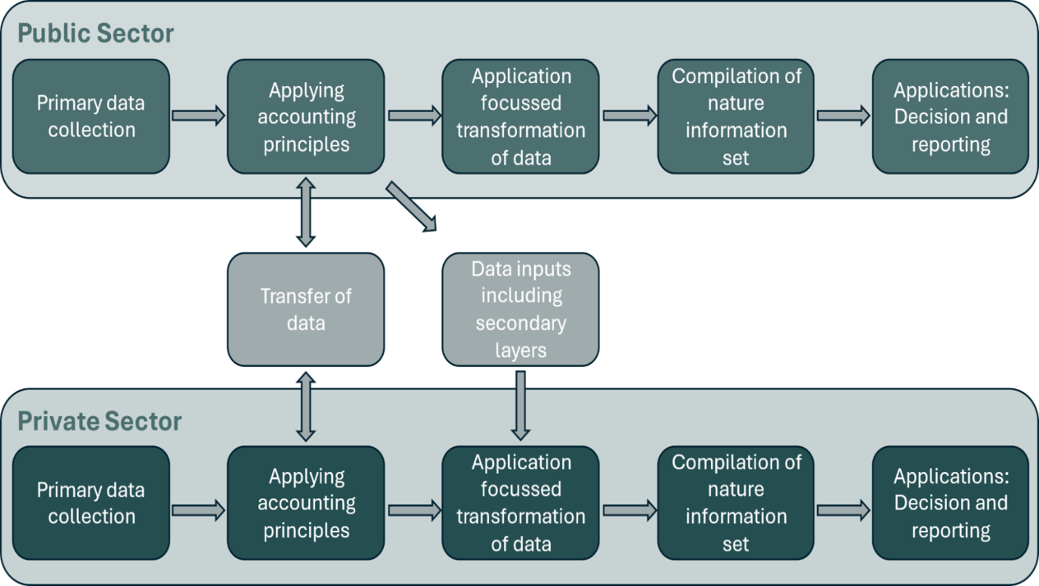
3. Applying Accounting principles
Ecosystem modelling and mapping
6.Applications: Decision and reporting
CSRD reporting
Management of priority sites (restoration,…)
2.2. Data inputs including secondary layers
Local vegetation + land-use maps
IUCN Red List of Habitats
Natura 2000 areas
Species data – BirdLife data page, …
2.1. Transfer of data
Data formatting
5. Compilation of nature information set
Extent + condition indicators
Framing/ alignment with metric frameworks (NPI, ESRS)
4. Application focused transformation of data
Local extent map of business site + landscape
Identification of priority ecosystem assets
Fragmentation
1. Primary data collection
Vegetation plots
Environmental variables
- Primary data collection
Habitat presence: Ideally presence of habitat types are determined and collected directly in the field. As this is not often done, but in data-rich scenarios (such as the UK site, and other sites in EUROPE and north America), much species presence data is available. Plant species presence data (points of coordinates+ species) from the European Vegetation Archive (EVA https://euroveg.org/eva-database/) and sPlotOpen (https://idiv-biodiversity.de/de/splot/splotopen.html) were used. These are both public and free datasets, but while sPlotOpen is available online for direct download, the EVA database requires an access request.
EUNIS2021 only includes habitats able to be identified by vegetation communities, and therefore for other relevant non-natural/non-vegetated habitat/land-use types, this classification was augmented with classes for constructed/artificial and inland surface water. The sources can be found in the appendix, along with other data sources used such as additional cropland points.
GBIF for v2?
Remote sensing data: Earth Observation data from the Sentinel 1 and 2 satellites were extracted at each habitat point using openEO (see Appendix). Ecological information reflecting climatological and soil properties is a second important source of information to distinguish habitats, and was similarly extracted (is this primary or secondary data?). This information needs to be available at the locations of the habitat points used to train the models, as well as for the full area onto which the model is projected to produce a habitat map in the next step of the NIP: Applying accounting principles, and therefore uses raster-format data.
  - Transfer of data
For the Vito workflow: Scripts/packages are provided on A-Track repository, and description in user manual. Extract the data for the biogeographic zone your site is located. Filter according to scripts (summarise Guidelines for habitat mapping reference data_ draft2.docx doc here). Each vegetation plot was assigned a habitat label according to the EUNIS habitat classification to level 3 using Pl@ntBERT, an open-access LLM that identifies EUNIS habitat types from lists of plant species.
  - Data inputs including secondary layers
In some cases, ecosystem maps will already be available for direct use, although this is not common at high enough resolution for business sites. When neither primary data nor appropriate maps are available, local vegetation maps and land-use information can be processed manually for a site. This was done for Sibelco’s Borneo site, using… (list sources).
Cite list of sources on repository? Or projects/frameworks that already have these lists – CircHive, SEEA/TNFD appendices,… refer to D2.2a if it’s in there, or include as appendix. The recently developed GeoPlantNet maps
Additional layers that provide other information on the ecosystems and species at the business site are also required to generate metrics. In this case, we used the IUCN Red List of Habitats and map of Natura 2000 areas to classify habitats of priority.
- Applying accounting principles
A catboost model was trained for each class hierarchically to predict habitat class presence ~ environmental variables and classify pixels into habitats. Then the model was run on the area of the business site, to generate a local extent map (10m resolution) of the most likely EUNIS habitat class present in each pixel based on the environmental values present. This was done for a 50km radius buffer around the site, so that landscape metrics could be produced, for two years (2020, 2024) to comply with SEEA EA accounting principles which require an opening and closing balance for an extent account.
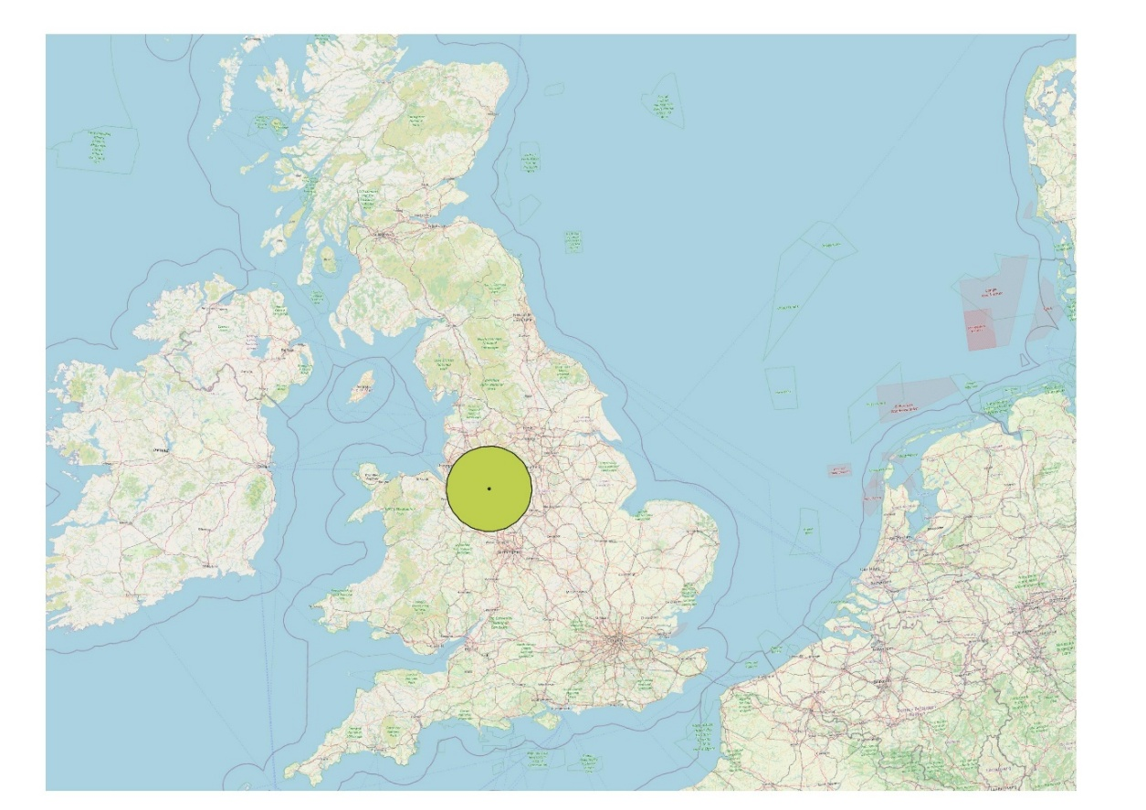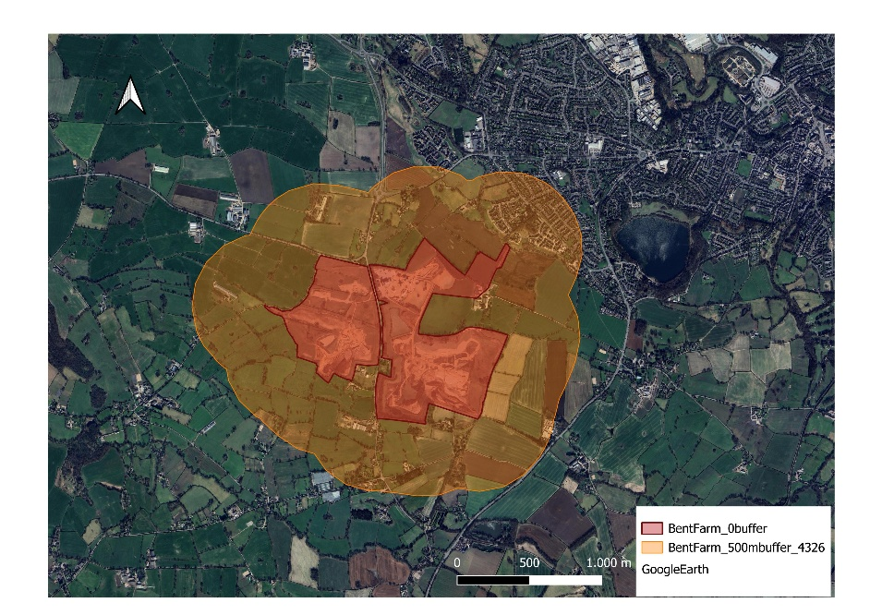
- Application-focussed transformation of data
Maps were generated for the extent of the quarry as well as the buffer. The area for each ecosystem asset was calculated in each polygon and summed to give area per ecosystem type. The threat status of each ecosystem type in the site was extracted from the IUCN Red List of Habitats website, and tabulated alongside ecosystem area. This information, as well as (…?ask Sibelco) was used to identify habitat types of priority for all of their European sites.

Year 2021, EUNIS lvl1 | Year 2024, EUNIS lvl1
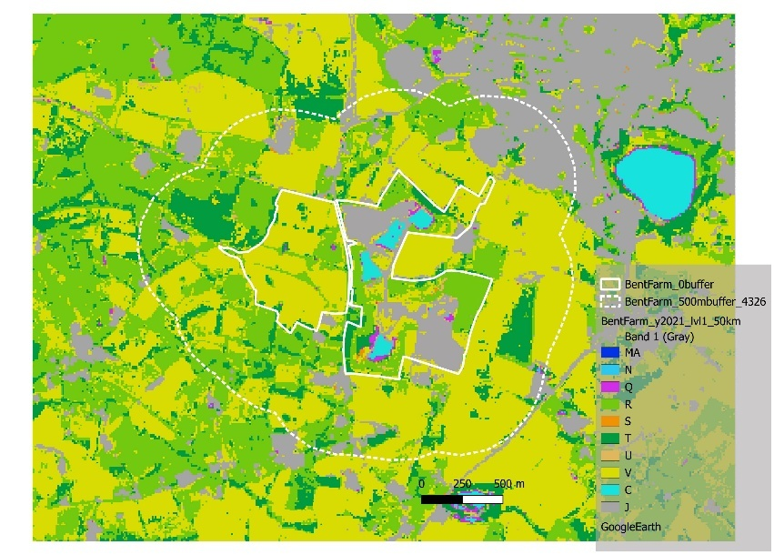 | 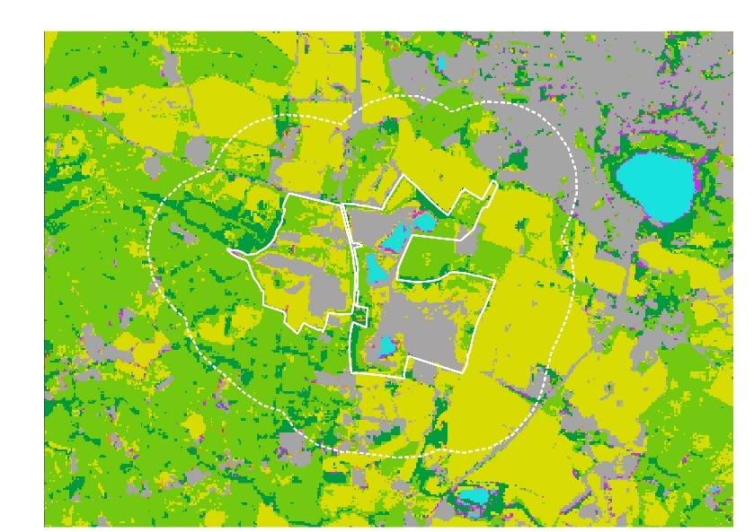
MA: Marine; N: Coastal; Q: Wetlands; R: Grassland; S: Shrubland; T: Forest; U: Sparse; V: Man-made vegetated; C: Water; J: Urban sealed
For Borneo site, NPI workflow/manual approach here.
- Compilation of nature information set
Area metrics were ready to be used for IND 1 and 1.1 of the NPI metrics. Ecosystems were further split into natural/semi-natural and the areas summed for each category to give IND 2. This was done for each year (note on change detection)
For the condition metrics of the NPI metrics, site condition was represented by … (get from Wies + we will choose extra metrics and calculate in 2026)
IND 4, defined as values and change in landscape connectivity, structural connectivity, and functional connectivity by NPI, was calculated as the MESH value (Keeley et al. 2021)using the FRAGSTATS program for a 50km buffer around the UK site.
Also cover cross walking to GET/other typologies.

Summarise the following tables (and additional condition indicators) into a clean list of indicators for nature info set.
IND 4 MESH values:
Site | Buffer | Typology | Level | Year | MESH
Bent Farm | 0m | EUNIS | 1 | 2021 | 13.46
Bent Farm | 0m | EUNIS | 1 | 2024 | 9.14
Bent Farm | 500m | EUNIS | 1 | 2021 | 44.50
Bent Farm | 500m | EUNIS | 1 | 2024 | 36.20
Bent Farm | 500m | EUNIS | 3 | 2021 | 26.63
Bent Farm | 500m | EUNIS | 3 | 2024 | 22.65
Bent Farm | 50km | EUNIS | 1 | 2021 | 10632.70
Bent Farm | 50km | EUNIS | 1 | 2024 | 14661.01
Bent Farm | 50km | EUNIS | 3 | 2021 | 2704.82
Bent Farm | 50km | EUNIS | 3 | 2024 | 3229.37
Capkala | 500m | GET | 3 | 2024 | 206.95
Capkala | 500m | GET | 4 | 2024 | 122.11

Bent Farm, per level1 class:
EUNIS code | GET code | GET name | MESH for buffer 50km |  | MESH for buffer 500m
 |  |  | y2021 | y2024 | y2021 | y2024
C | F | Freshwater | 34.947 | 33.619 | 0.014 | 0.014
N | MT | Marine-Terrestrial | 0.042 | 0.006 | 0.000 | 0.000
Q | TF1 | Palustrine wetlands | 1.153 | 0.796 | 0.001 | 0.000
R | T7.4 | Derived semi-natural pastures and old fields | 7192.493 | 12218.990 | 3.998 | 11.541
S | T3 | Shrublands and shrubby woodlands biome | 30.814 | 148.681 | 0.000 | 0.000
T | T4.4 | Temperate woodlands | 5.030 | 16.893 | 0.357 | 0.212
U | T3.4 | Young rocky pavements, lava flows and screes | 0.010 | 0.003 | 0.000 | 0.000
V | T7 | Intensive land-use | 859.919 | 189.940 | 38.004 | 21.021

Capkala, per class
GET class name | MESH for buffer 500m y2021 | Area m2
Plantations | 160.5266 | 461.84
Tropical flooded forests and peat forests | 45.2436 | 291.5
Tropical/Subtropical lowland rainforests | 1.1209 | 94.18
Derived semi-natural pastures and old fields | 0.0282 | 18.49
Sown pastures and fields | 0.0262 | 15.5
Small permanent freshwater lakes | 0.0053 | 5.88

IND 5 number of habitat patches, and total area of core areas (m2, patches 15m away from edge):
Bent Farm
 | y2024 |  | y2024
EUNIS lvl1 code | patches | core_area | patches | core_area
N | 3 | 0 | 2 | 0
Q | 55 | 0.21 | 130 | 0.24
R | 331 | 48.09 | 230 | 72.14
S | 56 | 0.08 | 143 | 0.11
T | 339 | 17.02 | 262 | 10.72
U | 53 | 0.11 | 21 | 0
V | 418 | 141.14 | 320 | 116.85
C | 7 | 2.96 | 7 | 2.91
J | 132 | 37.9 | 183 | 53.08

Capkala 2021
 | GET name | Level | patches | Core area | Area total
TF1.1 | Tropical flooded forests and peat forests | 3 | 124 | 226.44 | 291.5
T7.3 | Plantations | 3 | 57 | 400.09 | 461.84
T7.5 | Derived semi-natural pastures and old fields | 3 | 60 | 9.38 | 18.49
T1.1 | Tropical/Subtropical lowland rainforests | 3 | 96 | 60.6 | 94.18
F2.2 | Small permanent freshwater lakes | 3 | 11 | 3.14 | 5.88
? | Sown pastures and fields | 3 | 27 | 8.87 | 15.5
TF1.1.1 | Tropical flooded forests and peat forests in Southwest Borneo freshwater swamp forest | 4 | 124 | 226.44
T1.1.1 | Tropical/Subtropical lowland rainforests in Southwest Borneo freshwater swamp forests | 4 | 96 | 60.6
F2.2.1 | Small permanent freshwater lakes in Southwest Borneo freshwater swamp forest | 4 | 11 | 3.14

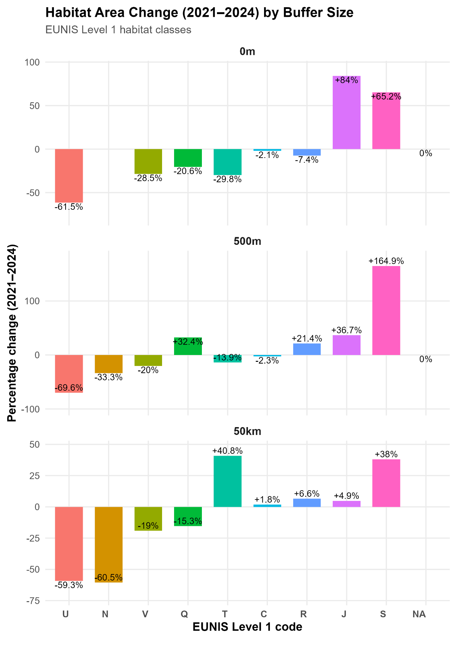

- Applications: Decision and reporting
CSRD/ESRS – add links here, for which indicators fit into which reporting part.
And talk about how Sibelco can use info on priority ecosystems/assets to manage their sites for restoration etc

Conclusions
Include how workflow specifically followed SEEA – eg opening/closing balances to generate account, data requirements, …
Identify any gaps, and how they can be filled by private data or will be addressed in future project outputs (eg WEED, GeoAtlas, CircHive?,…) – describe vegetation plots collected by Sibelco were included as private data to augment the public data and how sampling targets can be identified after this mapping process, or during data collection, creating a good feedback loop, link to T2.4.

Demo 2 - Assessing potential impacts and dependencies across value chain through Life Cycle Assessment

Demo 3 - Impacts and dependencies on ecosystem services at priority locations

Synthesis and recommendations

Including link to T2.4

Appendix
Additional ssources used for input data:
- Class J (Constructed industrial and other artificial habitats):
Total built-up surface and the built-up surface allocated to dominant non-residential (NRES) uses. Pixels with a value of ≥50% were extracted, and a random sample used. Data source: GHS-BUILT-S R2023A - GHS built-up surface grid, derived from Sentinel2 composite and Landsat, multitemporal (1975-2030), European Commission, Joint Research Centre (JRC). doi:10.2905/9F06F36F-4B11-47EC-ABB0-4F8B7B1D72EA.
- Class C (Inland surface waters):
Distribution of surface water 2021. Pixels of value 11-12 of the Global Surface Water seasonality layer (i.e. permanent inland water sources) were extracted, and a random sample used. Data source: Jean-Francois Pekel, Andrew Cottam, Noel Gorelick, Alan S. Belward, High-resolution mapping of global surface water and its long-term changes. Nature 540, 418-422 (2016). (doi:10.1038/nature20584), Source: EC JRC/Google.
- V1x (Cropland):
To augment the number of points in cropland classes in class V, we extracted the centre point locations of Class B (Cropland) from the Land Use/Cover Area frame Survey (LUCAS) polygon dataset. Data source: LUCAS Copernicus 2022 dataset, European Commission, Joint Research Centre (JRC) PID: http://data.europa.eu/89h/e3fe3cd0-44db-470e-8769-172a8b9e8874
Remote sensing sources used for model features:
Group | Predictor description | Original spatial resolution | Temporal resolution
Sen2 bands | B02, B03, B04, B08 | 10m | 2024
 | B05, B06, B07, B11, B12 | 20m | 2024
 | Clear observations | 20m | 2024
Sen2 indices | Normalized Difference Vegetation Index (NDVI) | 10m | 2024
 | Ashburn Vegetation Index (AVI) | 10m | 2024
 | Chlorophyll Index Red Edge (CIRE) | 10m | 2024
 | Near-infrared Reflectance of Vegetation (NIRv) | 10m | 2024
 | Normalized Difference Moisture Index (NDMI) | 10m | 2024
 | Normalized Difference Water Index (NDWI) | 20m | 2024
 | Modified Normalized Difference Water Index (MNDWI) | 20m | 2024
 | Ratio NDVI to NDWI (NDVIMNDWI) | 20m | 2024
 | Water Index (S2WI) | 20m | 2024
 | Red-Edge Position Linear Interpolation (S2REP) | 20m | 2024
 | Inverted Red-Edge Chlorophyll Index (IRECI) | 20m | 2024
Sen1 bands | Cross-polarization (VH) | 20m | 2024
 | Co-polarization (VV) | 20m | 2024
 | Difference VH-VV (VH-VVD) | 20m | 2024
 | Cross ratio VH-VV (VH-VVR) | 20m | 2024
 | Radar Vegetation Index (RVI) | 20m | 2024
 | Observations | 20m | 2024
Ecological data used :
Group | Predictor description | Original spatial resolution | Temporal resolution
Climate | Annual precipitation (mm yr-1) | 1 km | 1981-2010
 | Growing degree days heat sum above 5°C (gdd5) | 1 km | 1981-2010
 | Accumulated precipitation amount on growing season days TREELIM (gsp) | 1 km | 1981-2010
 | Mean temperature of the growing season TREELIM (gst) | 1 km | 1981-2010
 | Snow covered days (scd)[1] | 1 km | 1981-2010
DEM | EU DEM | 10 m | 2020
Inundation | Inundation - occurrence | 100 m
Population | Population density 2018 | 1 km | 2018
Soil | Soil - bulk density | 250 m
 | Soil - cation exchange capacity | 250 m
 | Soil - course fractions | 250 m
 | Soil - clay fraction | 250 m
 | Soil - pH | 250 m
 | Soil - sand fraction | 250 m
 | Soil - organic carbon | 250 m
Topography | Distance to inland water | 10 m

